**Microservices Implementation for Bank Account and Loan Services**

### **Objective:**

To create two independent Spring Boot microservices:

1. Account Microservice
2. Loan Microservice Each will expose REST endpoints and run on separate ports.

### **Folder Setup:**

1. Open File Explorer.
2. Create folder structure:

D:\<YourEmployeeID>\microservices\

### **Account Microservice Setup:**

#### **1. Create Project:**

* Visit: <https://start.spring.io>
* Fill the form:
  + Group: com.cognizant
  + Artifact: account
  + Dependencies: Spring Web, Spring Boot DevTools
* Click Generate and extract it to:

**2. Build Project:**  
cd D:\22b01a05d9\microservices\account  
mvn clean package

#### **3. Import to Eclipse:**

* Go to Eclipse: File > Import > Existing Maven Project
* Select: D:\ 22b01a05d9\ microservices\account

#### **4. Add Controller:**

* Package: com.cognizant.account.controller
* Class: AccountController

@RestController  
@RequestMapping("/accounts")  
public class AccountController {  
  
 @GetMapping("/{number}")  
 public Map<String, Object> getAccountDetails(@PathVariable String number) {  
 Map<String, Object> response = new HashMap<>();  
 response.put("number", number);  
 response.put("type", "savings");  
 response.put("balance", 234343);  
 return response;  
 }  
}

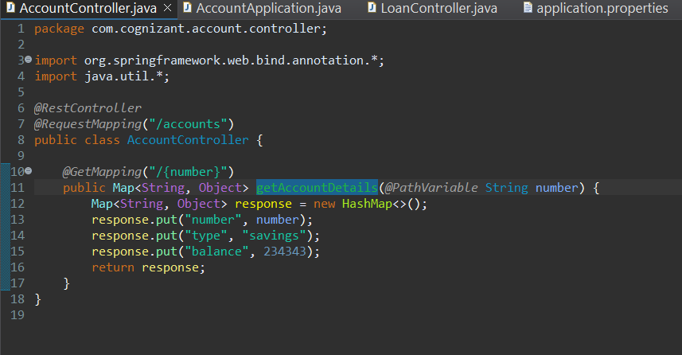

#### **5. Run and Test:**

* Run AccountApplication.java
* Test in browser/Postman:

http://localhost:8080/accounts/00987987973432

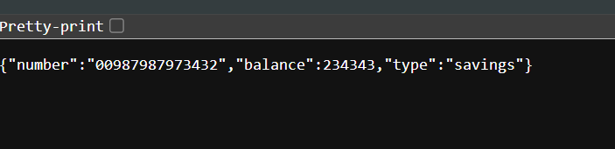

### **Loan Microservice Setup:**

#### **1. Create Project:**

* Visit: <https://start.spring.io>
* Fill the form:
  + Group: com.cognizant
  + Artifact: loan
  + Dependencies: Spring Web, Spring Boot DevTools

**2. Build Project:**  
cd D:\ 22b01a05d9\microservices\loan  
mvn clean package

#### **3. Import to Eclipse:**

* File > Import > Existing Maven Project
* Select: D:\ 22b01a05d9\ microservices\loan

#### **4. Add Controller:**

* Package: com.cognizant.loan.controller
* Class: LoanController

@RestController  
@RequestMapping("/loans")  
public class LoanController {  
  
 @GetMapping("/{number}")  
 public Map<String, Object> getLoanDetails(@PathVariable String number) {  
 Map<String, Object> response = new HashMap<>();  
 response.put("number", number);  
 response.put("type", "car");  
 response.put("loan", 400000);  
 response.put("emi", 3258);  
 response.put("tenure", 18);  
 return response;  
 }  
}

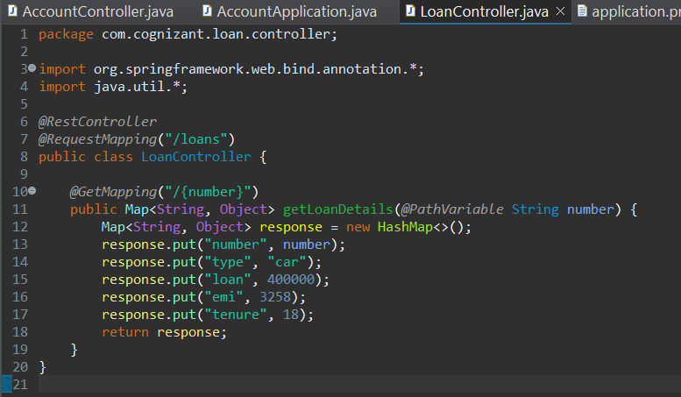

#### **5. Change Port:**

* Edit application.properties:

server.port=8081

#### **6. Run and Test:**

* Run LoanApplication.java
* Test in browser/Postman:

<http://localhost:8081/loans/H00987987972342>

